## 结果截图

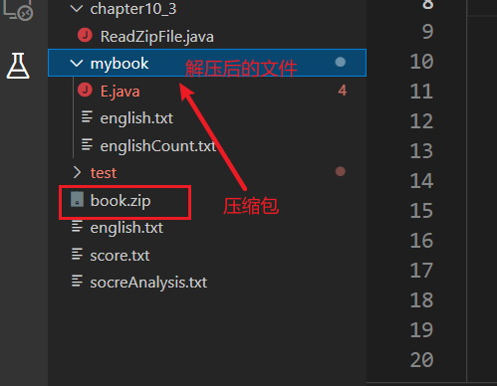

englishCount.txt文件中的内容，显示有乱码

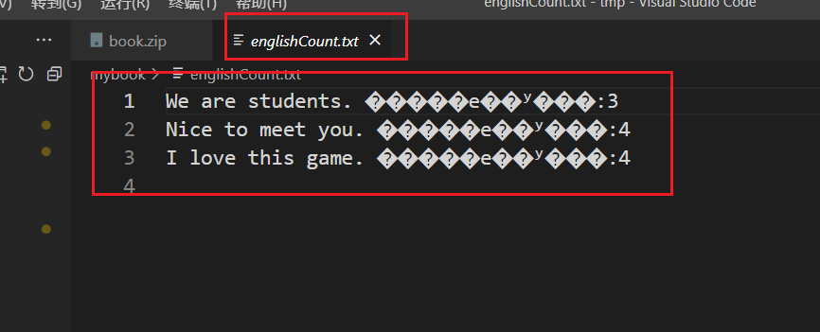

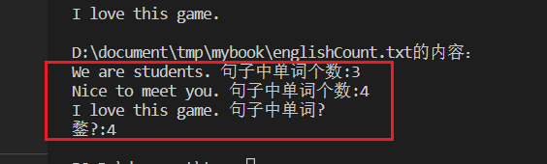

## 代码截图

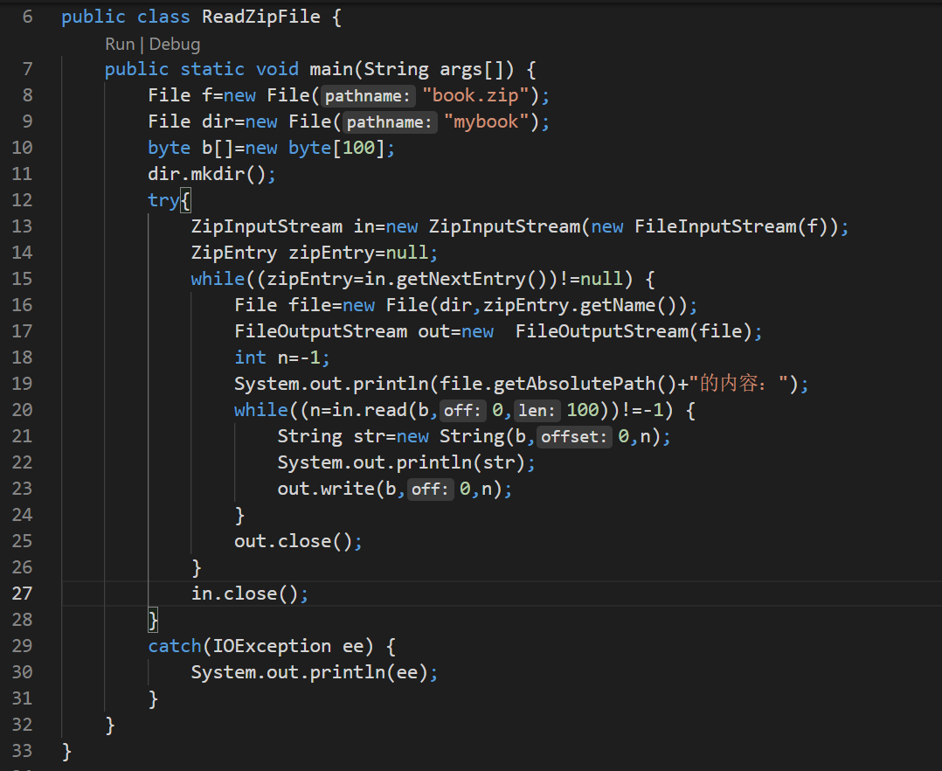

## 源码

package chapter10_3;

import java.io.*;

import java.util.zip.*;

public class ReadZipFile {

public static void main(String args[]) {

File f=new File("book.zip");

File dir=new File("mybook");

byte b[]=new byte[100];

dir.mkdir();

try{

ZipInputStream in=new ZipInputStream(new FileInputStream(f));

ZipEntry zipEntry=null;

while((zipEntry=in.getNextEntry())!=null) {

File file=new File(dir,zipEntry.getName());

FileOutputStream out=new FileOutputStream(file);

int n=-1;

System.out.println(file.getAbsolutePath()+"的内容：");

while((n=in.read(b,0,100))!=-1) {

String str=new String(b,0,n);

System.out.println(str);

out.write(b,0,n);

}

out.close();

}

in.close();

}

catch(IOException ee) {

System.out.println(ee);

}

}

}